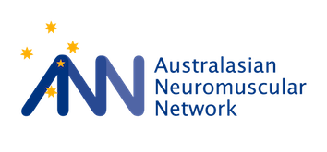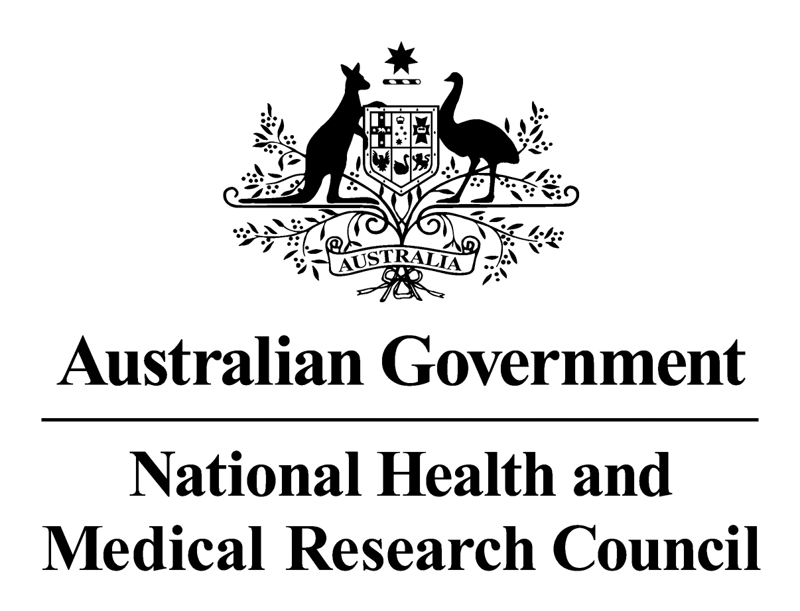
Australasian
Neuromuscular
Network (ANN) and the Centre for Research Excellence in Neuromuscular Disorders (CRE-NMD)

WORKSHOP REPORT
27th and 28th March 2014, Melbourne

Supported by:

MEETING THE CHALLENGES OF CARINGFOR CHILDREN AND ADULTS AFFECTED BY NEUROMUSCULAR DISORDERS IN AUSTRALIA AND
NEW ZEALAND

The Australasian Neuromuscular Network (ANN) is committed to establishing a cohesive, integrated neuromuscular network that enables people to work together across Australia and New Zealand for the well-being of patients.
We will provide a forum to advance and disseminate information, be a single voice to advocate for patients and guide best practice in diagnosis, care and treatment.
Our membership is open to all and includes patient organisations, clinicians, researchers, academics, industry and individuals with an interest in neuromuscular disorders.

Table of Contents
Executive Summary 5
Themes and Aims 7
Our Progress 8
Diagnosis and Prevention 9
Gene Discovery 9
Diagnosis 11
New technologies 11
International and national approaches to diagnosis 12
Global Alliance for Genomics and Health 12
Western Australia: the Neurogenetics Unit PathWest 12
Melbourne Genomics Health Alliance 12
European FP7 Program: Neuromics 13
Towards a national plan: current picture 13
Introduction 13
Queensland 15
New South Wales 15
Victoria 15
Northern Territory 15
Australian Capital Territory 15
Tasmania 15
South Australia 15
Western Australia 16
Gene testing in New Zealand – a snapshot 16
The “send it to Adelaide” national plan 16
Summary 16
Prevention 17
Duchenne muscular dystrophy newborn screening 17
Muscle Bank 17
Diagnostic algorithms 17
Genetic myopathies 17
Charcot-Marie Tooth disease 19
Communicating best practice via digital platforms 22
Pilot project: Charcot-Marie Tooth disease 22
Priority actions 25
Clinical Care 26
Gap analysis 26
Registries 26
Standards of Care 28
Clinical trials update - current 31
Facioscapulohumeral muscular dystrophy (CINRG network) 31
Duchenne muscular dystrophy muscle bank (CINRG network) ON HOLD 31
Natural history study of Becker muscular dystrophy (CINRG network) ON HOLD 31
Dysferlinopathy 31
Ataluren in DMD: open-label extension 32
Ataluren Phase III 32
Duchenne muscular dystrophy 32
Charcot Marie Tooth disease 33
Clinical trials update – pending 33
Duchenne muscular dystrophy 33
HSP72 co-inducer 33
Supporting Clinical Trials 33
Priority Actions 34
Allied Health and Nursing update 35
Priority Actions 35
Research 38
National patient database: Biogenix 38
National coordination 40
International coordination 40
Neuromuscular Community 41

Executive Summary
The ANN represents a critical step in the care and treatment of people with neuromuscular disorders – patients will benefit considerably through access to clinical trials (via international partners such as TREAT-NMD), new gene discoveries, improved diagnosis, new therapies - to achieve coordinated excellence of care throughout Australia and New Zealand.
The network is increasingly recognised as a peak body representing neuromuscular disorders. Members of the ANN were successful in securing combined grants from the National Health and Medical Research Council and the European Union 7th Framework Programme in rare disease research. These grants, which commenced in 2013, provide $2.5million toward establishing a platform to connect patient registries and to share data on rare diseases; to improve the diagnosis of rare disorders; and to reduce inequality of care in rare diseases.
Given the rare nature of the disorders, and that patients are located all over Australia and throughout New Zealand, a collaborative network to address diagnosis, prevention and treatment is extremely important. The ANN involves over 380 medical, nursing and allied health professionals, scientists and representatives from advocacy groups and will ensure that the best evidence from our clinical and laboratory based research is quickly translated into best clinical practice.
Research into neuromuscular disorders has entered a new era. Advances in sequencing technologies are accelerating gene discovery and the accuracy of diagnosis and number of patients diagnosed is rapidly improving. Clinical trials for novel drugs and gene-based therapies are currently underway and hold great promise. The ANN will provide a forum to advance and disseminate information and guide best practice in diagnosis, care and treatment. The ANN will promote integrated training programs for clinicians and researchers.
The best evidence from our clinical and laboratory based research will be quickly translated into best clinical practice. The ANN aims to address deficiencies in timely diagnosis and treatment, fragmented research efforts, shortcomings in data collection and lack of effective care for all individuals regardless of where they live.
Within the next five (5) years, the ANN has committed to:
- Increasing access for patients to new therapies by expanding clinical trial centres in Australia
- Expanding registries so that patients can access trials undertaken anywhere in the world
- Promoting the expansion of multi-disciplinary clinics
- Ensuring that 90% of patients will receive an accurate diagnosis
- Promptly translating research advances into improved health outcomes
- Making best practice guidelines widely available to clinicians
- Training clinicians of the future
.

ONE VOICE
OVER 380 MEMBERS
CLINICIANS NURSES PATHOLOGISTS PHYSIOTHERAPISTS PODIATRISTS RESEARCHERS ADVOCACY GROUPS

ONE GOAL
FOR EVERY INDIVIDUAL AFFECTED BY A NEUROMUSCULAR DISORDER TO HAVE EQUAL ACCESS TO CARE AND TREATMENT

Themes and Aims
The ANN supports the translation of best evidence into improved clinical outcomes for patients and their families. This requires a multi-disciplinary coordinated approach to integrating laboratory and clinical research, through to clinical trials and improvements in medical practice.
The ANN has established themes and aims to ensure that the best evidence is translated into best practice.
1. Patient Diagnostic Network
To coordinate a national collaborative diagnostic service and research network for neuromuscular disorders that is cost-effective, maximises availability and minimises duplication of services. This will include introduction of new diagnostic methods.
2. Patient Registries
To develop nationwide disease registers, based on accurate molecular diagnosis for patients with neuromuscular disorders, aligned with international models such as the TREAT-NMD registries.
3. Clinical Trials and Clinical Network
To establish a clinical trials framework for neuromuscular disorders accessible to patients around Australia and New Zealand.
4. Research
To facilitate the coordination of data collection and storage for large cohort studies initiated by individual investigators.

Our Progress

✔ Diagnosis and Prevention
✖ National diagnostic network
✖ Implement database to facilitate cohort studies and gene discovery
✔ National collaborative studies
✔ Accelerate gene discovery using next generation sequencing
✔ Increase rate of diagnostic success to 90%
✔ Population screening
✖ Guidelines
✖ Clinical trial readiness
✔ Develop new therapies
✔ Outcome measures
✖ National clinical trials framework
✔ International trials leadership
✖ Transition
✔ Training

Diagnosis and Prevention

Gene Discovery
WA and NSW, along with collaborators such as the Broad Institute, continue their focus on gene discovery. Next generation sequencing technologies have helped researchers identify more than 100 new neurogenetic disease genes within the last 18 months. Identification of new disease genes is crucially dependent on accurate clinical and pathological information and greatly facilitated by linkage analysis data from other family members wherever possible, including homozygosity mapping in consanguineous families.
Gene discovery not only provides information about new pathogenic genes for diagnosis, but also provides new insights into undiagnosed disorders and muscle biology and pathobiology. The ANN is one of the leaders in this area internationally.
The examples below demonstrate our efforts to immediately translate our research knowledge into a diagnosis for patients, while also generating new information through our research about what causes disease and potential disease genes and targets for new therapies.
The ANN gene discovery program is funded by NHMRC project grants, the Centre for Research Excellence grant and a European Union collaborative grant.
EXAMPLE 1
Diagnosis and Gene Discovery in the Foetal Akinesias and Congenital Myopathies - WA
- Performed whole exome sequencing or targeted sequencing using the NMD gene panel in 48 families
- Achieved a genetic diagnosis in 17 families (35%)
- In addition, 4 nemaline myopathy cases harbour a single pathogenic mutation in NEB (nonsense, essential splice-site)
- Three confirmed novel disease genes
  - KLHL40 mutations in NEM-foetal akinesia (AJHG, July 2013)
  - KLHL41 mutations in NEM-foetal akinesia (AJHG, Dec 2013)
  - One unpublished
- One potential candidate disease gene for lethal arthrogryposis
- Prenatal diagnosis has already been performed for families at risk of having children affected by KLHL40 and KLHL41 mutations.

Diagnosis
EXAMPLE 2
Congenital muscular dystrophy – NSW

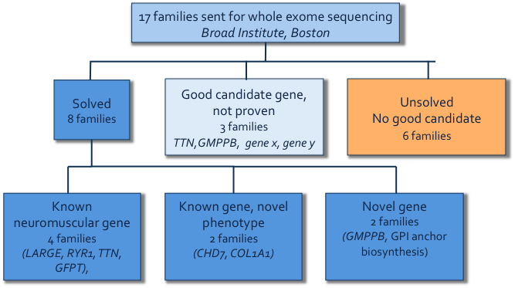

New technologies

Diagnostic gene testing has undergone significant evolution in the last two years, from Sanger sequencing based analysis of single regions of individual disease genes, to next generation sequencing-based analysis of multiple known disease genes simultaneously with selected gene panels and whole exome or whole genome sequencing. Answers can now be obtained for patients without a clear clinical diagnosis through “diagnosis by sequencing”, and that has opened doors for patients that were not readily investigated by previously available methods.
Next generation sequencing of targeted gene panels, the whole exome or the whole genome enables the evaluation of millions of sequences concurrently.
Targeted gene panel testing is aimed at a group of diseases that share similar clinical features, or a disease with complicated underlying genetic causes that involve many different genes. It requires a relatively certain clinical diagnosis.
Whole exome testing is designed to screen all known genes for the patient’s disease-causing mutation. Accurate clinical diagnosis and detailed clinical information remain invaluable in determining which might be the causative variant out of the hundreds of candidate variants identified in each patient.
Neither gene panel tests nor whole exome/whole genome testing cover every base of every targeted gene. Next generation sequencing methodologies have blind spots in high GC rich regions of the genome and repeated regions of the genome. They do not readily detect copy number variations or repeat expansions or contractions. Next generation sequencing is therefore not a panacea.
Targeted gene panels give greater coverage of the targeted genes than is obtained from whole exome or whole genome sequencing for the same amount of sequencing. Targeted panels therefore give greater throughput of patient samples on the available hardware.
There are several major challenges in developing and implementing next generation based tests in diagnosis. First, validating a next-gen-based test is much more complicated than validating a single gene test. There are considerably more variables to control for and more quality control metrics to consider. Second, next generation sequencing generates huge amounts of data. It requires greater computing power and informatics infrastructure and expertise. Third, we are dealing with several magnitudes more numbers of variants. It is very challenging to interpret the clinical significance for every one of them. It is challenging to know their significance individually and it is even more challenging to know their significance in combination or as a whole.
Despite these difficulties next generation sequencing diagnostic methods are be implemented through the ANN and are proving transformative.
The ANN is focussed on performing both targeted panel sequencing and diagnostic exome sequencing in parallel to offer the best results for patients. Our strength is our seamless connection between our research laboratories, pathology centres and our health professionals – our research findings can be readily made available as new disease genes are identified, and our research technologies are being investigated as useful diagnostic tools for a larger cohort of patients than existing methods. Our current experience is resulting in approx. 65% of patients being diagnosed using standard clinical and laboratory work-up for undiagnosed patients. The new technologies are providing answers for an additional 30%. Our aim is to increase the number of diagnosed patients to 90% within a standardised equitable diagnostic framework.

International and national approaches to diagnosis

Global Alliance for Genomics and Health
More than 40 countries and 150 organisations are members of the Global Alliance. The goal of the Alliance is to determine best practice methods of how to share genomic and clinical data, in an ethical and standardised way, as well as how best to analyse and present the data of clinical significance. The ANN is linked to the Alliance and patients in Australia and New Zealand will benefit from a common framework that supports data analysis and protects the autonomy and privacy of participating individuals.
Developing common phenotype ontology is important. PhenoTips is one example:
PhenoTips is an open source software tool for collecting and analyzing phenotypic information for patients with genetic disorders. The user interface closely mirrors clinician workflows so as to facilitate the recording of observations made during the patient encounter. This easy-to-use front-end, compatible with any device that runs a Web browser, is coupled with a standardized database back-end where phenotypic information is represented using the standardised Human Phenotype Ontology (HPO).
Collected data include demographics, medical history, family history, physical and laboratory measurements, and free-form notes.
In addition to data collection, PhenoTips automatically analyzes a wide range of measurements and plots live the corresponding growth curves. It also supports accurate diagnosis based on the entered data, and can suggest additional clinical investigations that can improve the diagnosis.

Western Australia: the Neurogenetics Unit PathWest
The Neurogenetics Unit in Pathwest, (Mark Davis, Nigel Laing) have implemented next generation sequencing diagnostics for neurogenetic and cardiogenetic disorders using a targeted panel of 336 disease genes and exome sequencing. The 336 genes on the panel comprise 277 neurogenetic disease genes and 59 cardiomyopathy disease genes. More than 400 patient samples have to date been analysed with the panel identifying causative mutations in many disease genes previously not analysed by the Unit, because of the cost in labour and consumables of traditional Sanger sequencing-based molecular diagnostics. Both the targeted gene panel and the exome sequencing are obtaining answers for those who previously would have had none.

Melbourne Genomics Health Alliance
The Melbourne Genomics Health Alliance (MGHA) is assessing the feasibility of introducing whole exome sequencing into clinical practice in the Victorian setting. The initial demonstration project will be a 12-month prospective study where whole exome sequencing with bioinformatically-targeted analysis will run in parallel with usual investigation. The aim is to demonstrate that whole exome sequencing should be available to all as a cost effective diagnostic option offered via Medicare.

European FP7 Program: Neuromics
The ANN is also linked to an international project funded by the European Commission to use the most sophisticated omics technologies to increase the number of patients with a genetic diagnosis, develop biomarkers of disease, improve our understanding of disease and develop therapies. Through Nigel Laing as an overseas partner of the FP7 Neuromics program, the ANN is contributing to and benefiting from sharing information and platforms, and patients will benefit from this international approach to diagnosis.

Towards a national plan: current picture

Introduction
While the ANN has sequenced similar numbers of exomes to counterparts in Europe (as reported at the European FP7 meeting in February 2014) and our diagnostic success rate is improving and on par internationally, Australia does not yet have a coordinated national funded approach for the diagnosis of neuromuscular disorders. The perception of ANN members was that the molecular diagnostic situation around the country currently is a “dog‘s breakfast of ad hoc arrangements hanging by a thread” [Prof Nigel Laing].
A session of the 2014 ANN Meeting was therefore devoted to a fact-finding survey of the ad hoc arrangements around the country.

Table 1: Who performs genetic testing in Australia?
[Taken from: NHMRC Medical Genetic Testing – Information for Health Professionals 2010]:

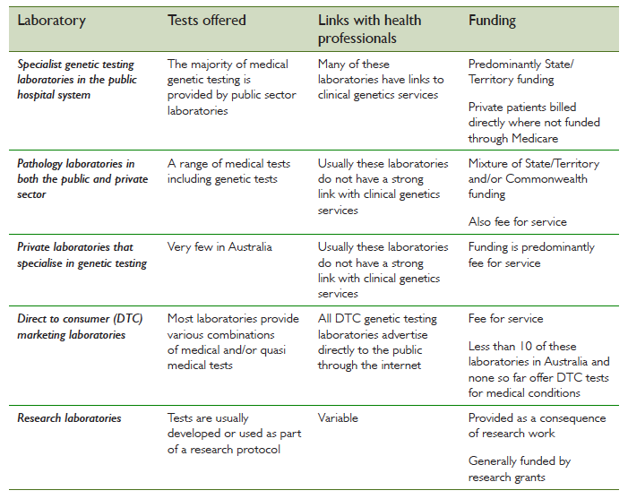

While most diagnostic laboratories offering genetic testing are accredited to the NATA/IANZ standard, most research laboratories are not. The availability of a genetic test in a particular laboratory may reflect the research interests of that laboratory. For example, a laboratory that undertakes research into a particular genetic disease might also offer, as part of its research work, a DNA diagnostic service for that disease.
The ANN has published a list of neuromuscular genetic testing available in NATA accredited laboratories on its website - http://www.ann.org.au/neuromuscular-gene-tests/.

Gene testing in Australia – a snapshot

Queensland
- Paediatric neurologists can order testing and there have been no limits placed on this
- Testing is done through QLD pathology
- Most tests are $1,000-2,000 and performed as requested (it is more expensive to order a muscle biopsy).

New South Wales
- Funding for tests differs across hospitals pathology, patient or neurology department
- Adult services neurologist: patient pays for testing, sometimes the neurology department will pay.
- Concord: If a patient is seen within the hospital then testing is billed to NSW Pathology, patients pay for samples outside of the hospital setting
- Westmead: the testing is paid for by the Western Sydney Genetics Program (WSGP), which has a budget for testing. Clinicians must apply to the ‘gatekeeper’ clinical geneticists within WSGP for approval of testing. All appropriate testing is funded if the cost is reasonable and sufficient reason for testing, including carrier testing, is given.

Victoria
- Like NSW, funding for tests differs across Hospitals pathology, patient or neurology department.
- Overseas testing is not funded and it is most often difficult to organise for funding of tests outside of the state (national).
- Sometimes costs are funded by individual departments, area health services, or the patient.
- Victorian Clinical Genetics Service (VCGS): carrier testing/cascade testing – cost passed onto families
- Duchenne muscular dystrophy: have to order biopsy if mutation not found by multiplex ligation-dependent probe amplification (MLPA), as support for further genetic testing not provided
- St. Vincent’s Melbourne Neuromuscular Diagnostics Laboratory: Mitochondrial DNA tests funded by Department of Human Services.

Northern Territory
- Covered by VCGS (until end of 2013 was covered by SA)
- NT has budget for genetic testing.

Australian Capital Territory
- Patient is billed; if the patient cannot afford the test then day clinic takes patients for bloods since then cost of testing covered by health system
- Clinical genetics very slow (>1 yr).

Tasmania
- Supported with a budget and testing performed by VCGS.

South Australia
- Children’s Hospital clinical geneticists sign off on test orders, (act as gate keepers)
- Adult neurologists can order a test directly if case discussed with a geneticist.
- All cascade testing covered
- Funded by genetic service,
- Testing funded up to ~$2,000 limit
- Managed by SA pathology.

Western Australia
- Covered by Diagnostic Genomics budget within PathWest for genetic testing
- All the consortium of laboratories within Diagnostic Genomics have to operate within the budget.
- The budget has not grown rapidly.
- Some patients billed if seen in private rooms.

Gene testing in New Zealand – a snapshot
A national genetic service was established in 2012. Genetic Health Service New Zealand (GHSNZ) provides genetic testing throughout NZ and is funded by the public health system, the National Health Board.
Access to genetic testing is better than in Australia; however there are some limitations with neurologists unable to consult in different areas, as there are cost implications, and there could be an improvement in how geneticists and neurologists interact.
Within the paediatric population, genetic testing is also available through Starship Hospital in Auckland.

The “send it to Adelaide” national plan
One shining example of a successful national diagnostic plan for genetic disorders in Australia is the ‘send it to Adelaide’ plan for lysosomal etc disorders. The centre of excellence that is the National Referral Laboratory for Lysosomal, Peroxisomal and Related Disorders, Women’s and Children’s Hospital, Adelaide, provides a service for samples sent from all over the country for analysis for these rare conditions. In some jurisdictions around the country different health services or particular departments pay for this, in other jurisdictions it falls to the patient to pay. Not withstanding the vagaries of paying for the service around the country, this Centre of Excellence approach has worked well over many years.

Summary
In Australia, the jurisdiction-based approach to funding genetic tests has led to inconsistent practices and inconsistent accessibility to testing between states and territories. The perception of ANN members that it is a “dog’s breakfast”, was more than confirmed by the meeting. The situation in NZ is significantly better with a national coordinated approach.
In the Australian context, there are accredited laboratories that are able to test for many known disease genes and the number of genes that they can test has increased rapidly through the implementation of next generation sequencing diagnostics. There is also an informal arrangement through a national system of centres of excellence, where testing is sent to experts in the respective disease areas. However, in Australia, in some areas it falls to the patient to pay, in others, to different health services or particular departments. This inequality impacts on patients, where funding boundaries place limitations on accessibility to an accurate diagnosis and appropriate treatment.
For the sake of the patients and families affected by neuromuscular disorders, a small working party from the ANN should initiate discussion with State and Federal health services about the implementation of a national plan for diagnosis of neuromuscular diseases.

The ideal system would build on the services already provided by the States with superadded Federally funded resources. For example, some standard tests could be funded Federally, such as exome-based diagnosis, though this would require rigorous gate-keeping. Generated data should be interpreted through a system of centres of excellence around the country.

Prevention

Duchenne muscular dystrophy newborn screening
Data collection for the normal data study being carried out in the NSW Newborn Screening Laboratory is nearly complete. The results of this study will inform routes to best practice Duchenne newborn screening.

Muscle Bank
The Victorian Neuromuscular Laboratory was established in 1970 and contains approx. 14,000 specimens.
The value of a muscle biopsy in diagnosis cannot be underestimated. A muscle bank will provide a valuable resource for researchers, to understand the mechanisms of disease, improve diagnosis and identify novel genes and potential new therapies.
An internet-based database (Biogenix) would be used to store the de-identified muscle information. This would be held nationally but the physical tissue would be stored locally within each laboratory.
Individual banks would be maintained locally, with sharing of specimen information available through a common database.

Diagnostic algorithms

Genetic myopathies
Very frequently after performing the specific gene test requested there is no diagnosis, because the specific gene test requested was not the correct gene to ask for. A broad panel approach may be one option to help solve the diagnostic dilemma for the clinician.

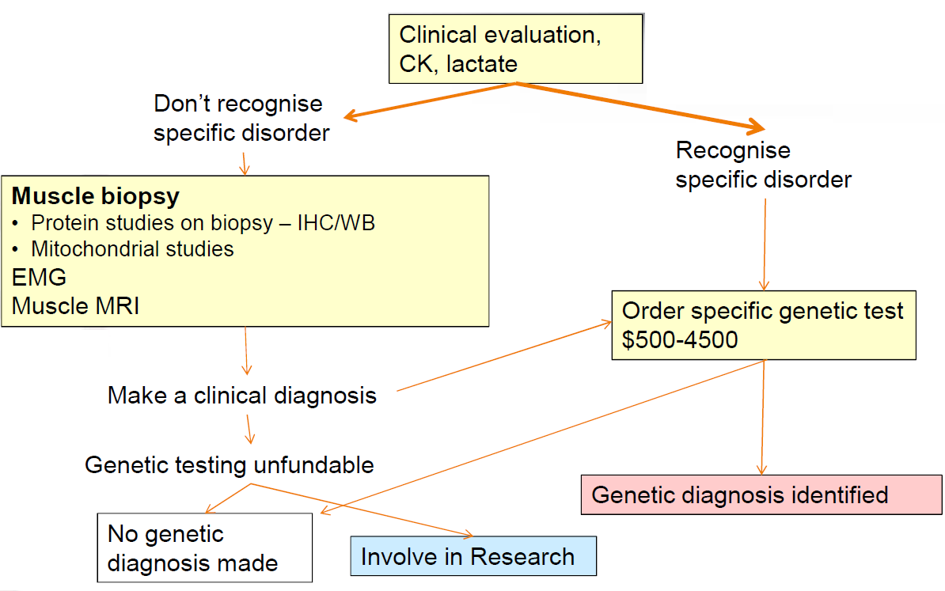

Figure 1: Previous paradigm

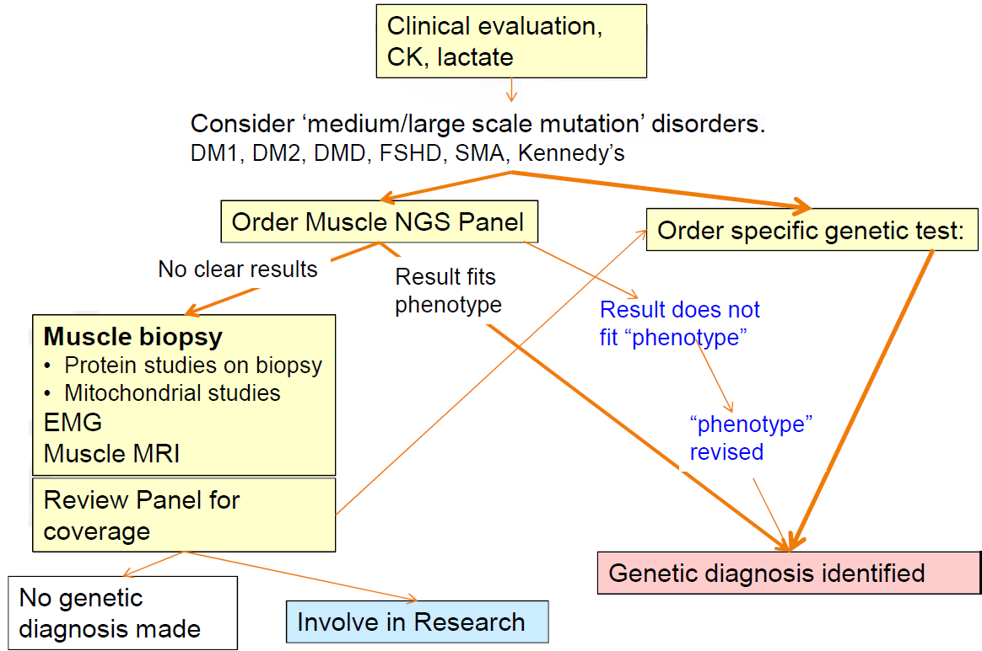

Figure 2: Current paradigm

Key differences:
- Panels will improve diagnosis in:
  - mutations in large genes (NEB, TTN, RYR1), rare disorders, atypical phenotypes,
  - highly heterogeneous disorders
- Panels will speed time to diagnosis, save money

Challenges:
- Not all mutations are found by panels – will miss:
  - SMA, DM2....
  - moderate deletions/duplications
- Regions of genes that are not captured well (high GC content – e.g. FKRP)
- Repetitive regions - including 24 exons in each of TTN and NEB,, etc)
- Checking coverage
- Lab: Distinguishing mutation(s) from polymorphisms
  - Phenotype is important

Charcot-Marie Tooth disease
- A group of inherited neuropathies with a broad range of phenotypes, inheritance patterns and causative genes
- More than 70 genes causative of CMT have now been identified, more than half of these since 2009
- Sanger sequencing in CMT is less useful because of the large number of genes implicated, the phenotypic variety of many genes, and the fact that many neuropathy syndromes are genetically heterogeneous
- Testing for most of these syndromes is not currently available - on either a clinical or research basis - in Australia.
- Approximately 60% of patients have CMT1
- CMT1A, caused by a 17p duplication containing the PMP22 gene
- CMT1B, caused by mutations in MPZ
- CMTX, most often caused by mutations in GJB1 (Cx32).
- Approximately 40% of patients will have axonal neuropathies
- 25% distal HMN, 25% HSN and 50% CMT2
- Together, mutations in PMP22, MPZ and Cx32 account for ~75% of all cases of CMT1 and ~ 40% of all cases of CMT
- Guidelines based on phenotyping and sequential Sanger sequencing
- Where all known genes can be sequenced: a diagnosis made in >60% of patients
- Sanger sequencing: no longer the most efficient, rapid or cost-effective means of diagnosis
- Leading centres internationally have now adopted next generation sequencing as a routine diagnostic approach
  - Most mutations have been found in known CMT genes
  - Genes that not previously examined missed by Sanger sequencing
  - Next generation sequencing likely to be even more productive in centres such as Melbourne (limited availability of Sanger sequencing other than for PMP22 and GJB1)

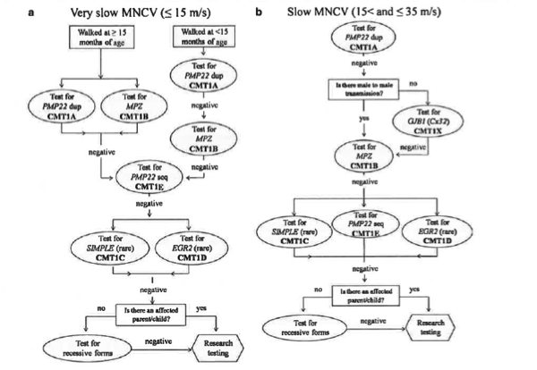
Figure 3: Diagnostic algorithm for CMT types 1 and 4 - current. Saporta, A. S., et al. (2011). "Charcot-Marie-Tooth disease subtypes and genetic testing strategies." Ann Neurol 69(1): 22-33.

Melbourne Genomic Health Alliance
Funding made available through the Melbourne Genomics Health Alliance is being used to lay a robust foundation for the viable and sustainable integration of genomics in health care practice.
Three separate work streams are currently underway and aim to:
• Establish collaborative and shared approaches to the analysis, management and application of genomic information and the development of a workforce skilled in these areas.
• Conduct and evaluate a demonstration project to test shared approaches and technical and procedural feasibility, determine future costs and build clinical experience.
• Develop a sound plan for implementation and funding of the full vision, based on an evaluation of the demonstration project.

Demonstration project – Peripheral neuropathy:

• A study of whole exome sequencing in a cohort of patients with probable genetic neuropathy, in whom a definitive diagnosis has not yet been made.
• The cohort includes subjects from the neuromuscular clinics at RMH and RCH
• An index patient from each kindred will undergo whole exome sequencing, with a plan to Sanger sequence parents where required for genetic confirmation
• Testing on other family members will be arranged separate to this study.
• Relative value of different diagnostic systems unclear
• Gene panels vs WES vs WGS +/- addition of CGH and linkage data
• Regardless of genetic techniques used, clinical, neurophysiologic and pathologic phenotyping remains critical

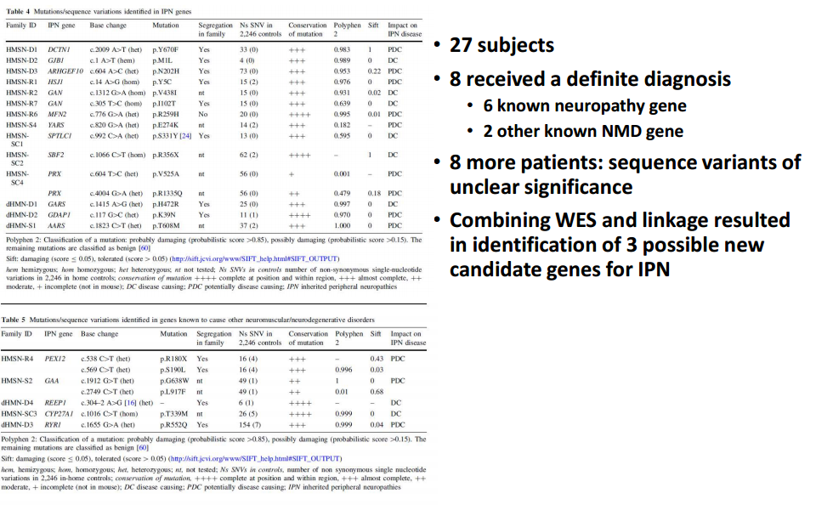
Figure 4: Diagnosis of patients using MGHA flagship pipeline.

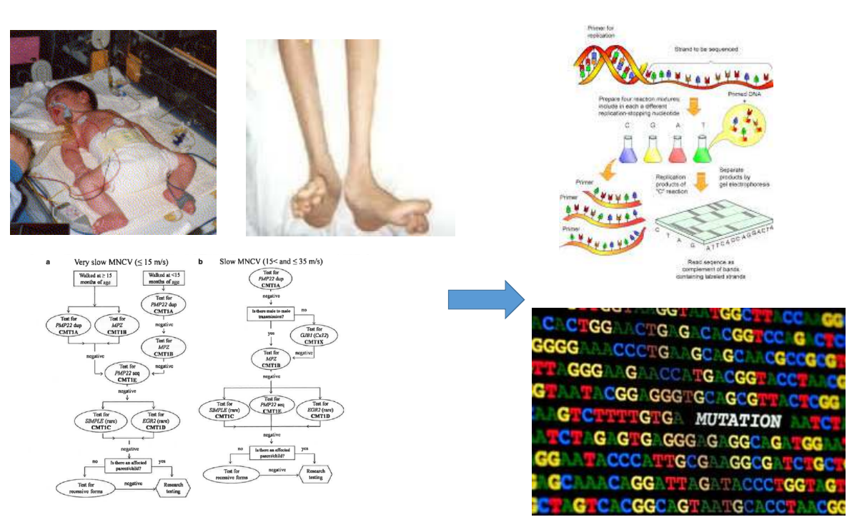
Figure 5: The future of diagnosis.

Communicating best practice via digital platforms

Pilot project: Charcot-Marie Tooth disease

We are seeking innovative ways to communicate NMD research in to health care. Digital platforms and tools enable access to information beyond conventional publication channels. They include tools like mobile apps, web-based diagnostic tools, wiki platforms and a great deal more.

The goal of this project is to accelerate the delivery of NMD research to clinicians (and into practice) by communicating research via a digital platform that is innovative, interactive and accessible, and ensure the platform addresses needs and reflects current trends in how clinicians retrieve and use research.

The reasons for doing this:
- Because of the lag in research finding its way in to practice and difficulties for practitioners (and the public) in accessing research
- Because of a scarcity of resources and expertise in NMD, and that the diagnosis and management of NMDs is challenging in all tiers of health care
- Practitioners want access to evidence-based information (around diagnosis and management of NMD).

- In 2003, 22 causative genes for CMT identified, by 2014 (March), 71 causative genes for CMT identified
- NGS will see more causative genes for CMT identified
- This is the case for many NMDs

How will clinicians keep up?

Figure 6: CMT gene discovery timeline.

There is a need for a simple diagnostic tool.

- Molecular diagnosis rate in patients attending the London CMT clinic is much higher than those attending other clinics
- 63% of patients attending the specialist clinic were diagnosed versus 38% in those not attending (p=0.003) Murphy et al 2012
- Similar in Germany
- 55% vs. 30% Gess et al 2013

Aims:
- Develop an app that digitises a published diagnostic algorithm for Charcot-Marie-Tooth disease (see Figure 7).
- Develop the app as a proof of concept to expand to other NMDs

Target audience:
- Clinicians

The vision beyond this pilot project is to develop a digital platform incorporating clinical diagnostic tools, standards of care and management guidelines for other neuromuscular disorders.

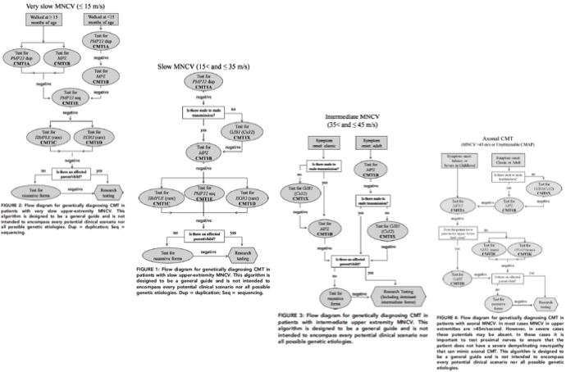

Figure 7: Diagnostic algorithm for Charcot Marie Tooth disease types. Saporta, A. S., et al. (2011). "Charcot-Marie-Tooth disease subtypes and genetic testing strategies." Ann Neurol 69(1): 22-33.

Priority actions

- Develop a discussion paper for state and federal government approach, including a health economic argument – What is the best national approach?
  - What is the ideal national plan?
  - What is the best way to fund a national diagnostic laboratories plan?
  - Even in this room, could we all agree on what the ideal funding model should be?
  - Could even two people in this room agree on what the ideal funding model would be?
  - What precedents are there?
  - Map what is happening nationally in terms of funding for diagnosis

- What was the path of diagnosis and how much did this cost. Undertake a health economic assessment of genetic testing – retrospectively using WA and NSW data and prospectively using Melbourne Genomics Health Alliance data.

- List of contact people – ‘content experts’ – in Australia and New Zealand

- Parallel development of panels and exome sequencing, with a focus also on the 25% of people where we don’t get an answer for WGS, RNA based testing etc.

Clinical Care

Gap analysis
- As part of the FP7 Rare Best Practices Project, the CARE-NMD survey will be implemented throughout Australia and New Zealand. It is the largest ever survey of care and quality of life for DMD. The survey was developed by Dr Jan Kirschner to evaluate current practices and has been run in 7 countries with a 64% response rate.
- The survey will be a powerful tool to gather evidence for a business case requesting support for establishing new and expanding existing clinics, with the aim of reducing inequalities for patients.
- The survey is being developed for circulation in Australia and New Zealand, with some modification to the CARE-NMD questions so as to have a local context.
- Ethics has been finalised in NZ, while submissions are being finalised for NSW (VIC and WA to follow).

Registries
- DMD Registry data is possibly only 30% of forecast registrations.
- Not all jurisdictions have ethics approval for spinal muscular atrophy and myotonic dystrophy registries [NZ, WA, NSW and Vic jurisdictions have ethics approval].
- Data successfully uploaded to TREAT-NMD database from the DMD and SMA registries.
- Participation in two TREAT-NMD enquiries.
- TREAT-NMD has submitted two papers for publication on the DMD and SMA data.
- The TREAT-NMD Duchenne muscular dystrophy registries: conception, design and utilisation by industry and academia.
- Mapping the differences in care for > 4000 Spinal Muscular Atrophy patients, a survey of 23 national registries.
- Email alert created for curators when a person in their jurisdiction is registered.
- Longitudinal data storage installed on DMD and SMA Registries.
- Establishment of a formal process for applying for access to the NMD Registry data that includes approval from the NMD Advisory Committee.
- People registered on the registry in one jurisdiction can be transferred to another jurisdiction if they move interstate.

Table 2: Snapshot of current NMD registry registrations.
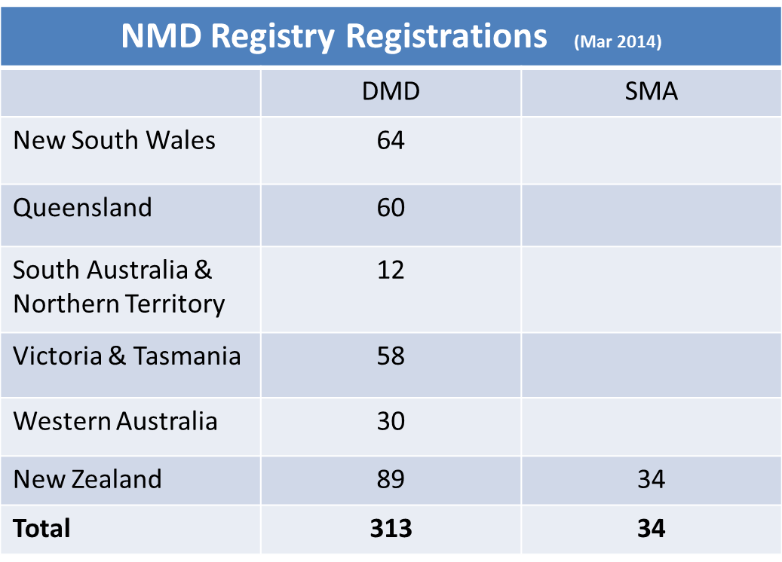

Table 3: Proportion of clinical and genetic data entered.
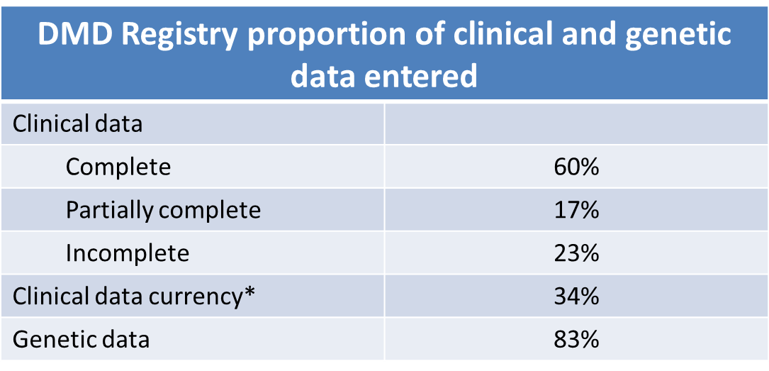
*Currency: data update in the last 365 days.

Standards of Care
Members of the ANN/CRE-NMD have secured NHMRC-EU funding to improve diagnosis for rare diseases and establish an integrated platform connecting registries, biobanks and clinical bioinformatics for rare disease research (RAREBestpractice, Neuromics and RDConnect). The RAREBestpractice project has a number of aims and the ANN/CRE-NMD will focus on the following:
Aim 1: To collate and evaluate existing best practice documents for rare diseases
There is a need to synthesise & review evidence on rare diseases to identify our strengths (and weaknesses) in particular areas and to guide further research and direct care.
We are thus undertaking a systematic review of existing guidelines and standards of care for neuromuscular disorders. The collection of guidelines will be guided by a search protocol developed by our EU partners. Those retrieved will be appraised and loaded to a central database of guidelines currently being built by our EU project partners. The guidelines database site (currently under construction) can be viewed at: http://www.rbpguidelines.eu/
Aim 2: Undertake a gap analysis to guide improvement in clinical care
- CARE-NMD survey adapted to Australian & New Zealand setting. Questions cover:
  - Current treatment
  - Demographics
  - Health status
  - Access to specialist clinics
- Awaiting ethics approval
- Anticipated distribution from April 2014
- Aiming for 300 responses from across Australia
- Requires different approach in distribution- through clinics and MDA’s throughout Australia
- Includes age specific quality of life questionnaires
- Developing an online version through Survey Monkey

Table 4: Response rates for CRE-NMD survey through Europe.
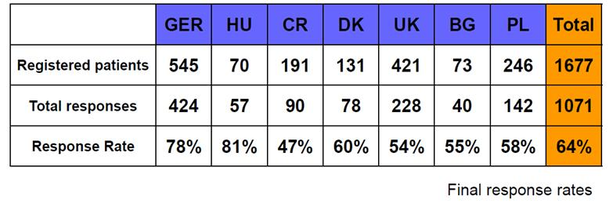
The European results have reported:
- Loss of ambulation has been delayed through current care practice including steroid treatment
- Most but not all patients are offered steroid treatment
- Number of non-ambulant and adult patients is increasing
- Adult patients receive less physiotherapy and are often not seen at a neuromuscular centre
- Patients seen at neuromuscular centres receive more information and treatment according to recommendations

Aim 3: Expand patient databases
- Australian Rare Disease Registry Framework has been built as a modular system and can be deployed to manage a variety of disease and disorder patient data.
- Australian and New Zealand Neuromuscular Disorders Registries expanded to include:
  - Duchenne muscular dystrophy*
  - Spinal muscular atrophy*
  - Myotonic dystrophy (soon to be released)
*These registries are linked to TREAT-NMD global registries

Aim 4: Develop best practice guidelines using agreed methodologies
We are currently planning our approach, which will involve linking with the NIH Inherited Neuropathies Research Consortium to develop international best practice guidelines, or we will develop national guidelines, using a methodology developed under RARE-Bestpractices group EU.
Clinical Trials
The ANN aims to consolidate a clinical trials network involving centres in Australia and New Zealand, giving all patients access to new clinical trials, ensuring immediate access to new therapies.
In order to ensure access to new therapies, the Australian and New Zealand sites must:
- Know our patient numbers and have patients well characterised
- Adhere to Standards of Care
- Identify expertise and experience in conducting clinical trials
Australia is considered, along with the US, UK and Europe, as a viable first line site in which to conduct clinical trials. Our strengths are that we have experience and world-class expertise in neuromuscular disorders, in diagnosis, clinical care and research. In addition, we are a relatively small neuromuscular community with a positive history of close collaboration.
It will take a significant increase in funding to establish clinical trials in each state. In the meantime, the ANN will support local evaluator training to support less intensive trials that can be undertaken through local clinics.
Progress has been made in the development of disease specific outcome measures. NSW and VIC are leading studies to develop outcome measures for clinical trials. The CRE-NMD is supporting PhD scholarships for allied health students to undertake studies to determine normative data against which disease specific outcome measures can be identified.
The next five (5) years will be challenging, however there has been progress towards identifying clinical trial projects that can perform at sites without established clinical trial infrastructure. The Neutriceuticals trial will be undertaken across VIC, QLD and NSW, and the VIC serial casting in DMD project has been expanded into Sydney Children’s Hospital.
There has also been progress towards providing training for allied health professionals and their involvement in clinical trials. There are fellowships provided through VIC and NSW, however there needs to also be a more formal exchange of trainees and encouragement and support for new trainees to specialize in neuromuscular disorders.

Clinical trials update - current

Facioscapulohumeral muscular dystrophy (CINRG network)
- A multicentre collaborative study on the clinical features, expression profiling, and quality of life of infantile-onset facioscapulohumeral muscular dystrophy (ACH0311)
- 50 subjects, single visit cross-sectional study
- Onset <11 years
- Victoria: 1 subject enrolled, 2-3 more expected
- NSW: 1 subject enrolled, 1-2 more expected

Duchenne muscular dystrophy muscle bank (CINRG network) ON HOLD
- Duchenne muscular dystrophy Tissue Bank for Exon Skipping (CHAR0312)
- Tissue bank to collect blood and skin samples
- Participants: 60 boys >4y, DMD amenable to exon skipping
- Deletions of exons 44, 45-50, 45-52, 46-47, 46-48, 46-51, 48-50, 48-52, and 49-50
- Victoria: Ethics submission abandoned
- Current participating sites:
  - Carolinas Medical Center, Charlotte, NC
  - Children's Hospital of Pittsburgh

Natural history study of Becker muscular dystrophy (CINRG network) ON HOLD
- A Natural History BMD Study to Predict Efficacy of Exon Skipping (PITT0112)
- Aiming to enrol 80 participants with BMD ages 4y +
- Inclusion: BMD with mutations potentially amenable to exon skipping therapies
- Victoria: Ethics abandoned as skin biopsy part of protocol, not acceptable to HREC
- Current site: Children's Hospital of Pittsburgh

Dysferlinopathy
- Natural history study monitoring motor abilities and symptoms over 2 years, in patients >10y with LGMD2B
- Primary outcome – assessment of potential outcome measures for clinical trials
- Recruitment now complete
- 11 sites internationally
- ANZ site: NSW

Ataluren in DMD: open-label extension
- Study of Ataluren for Previously Treated Patients With nmDBMD in Europe, Israel, Australia, and Canada
- Primary outcome measures: Safety and tolerability
- Secondary outcome measures:
  - Ambulatory:
- Change on 6MWT, timed function tests and NSAA
  - Non-ambulatory:
- Change in ADLs (EK scale), pulmonary function
- Victoria: Ethics approval, 6 patients enrolled
- NSW: Ethics approval, 3 subjects enrolled

Ataluren Phase III
- International multicentre placebo-controlled randomised low-dose vs placebo
- Similar protocol to previous (phase 2B) trial
- NSW: CHW 3 pts to be screened, 4 potential pts from NZ
- VIC: 5 patients to be screened, 3-4 more potentials
  - Two subjects referred from SA

Duchenne muscular dystrophy
- Zoledronic acid in DMD
  - Aim: To assess efficacy and safety of zoledronic acid, vitamin D and calcium vs. vitamin D/ calcium in 40 boys with steroid-treated DMD.
  - Primary outcome measure: BMD/ bone turnover over 12m
  - 22 subjects recruited: RCH 15 pts, CHW 3, PMH 4
- Nutriceuticals in DMD
  - Sites: Melbourne, Brisbane, CHW, ?SCH
  - Recruitment target: 54 (85% power)
  - RCH VIC: 18 enrolled, 2 drop-out, 1 potential subject
  - CHW: 7 enrolled, 1 drop-out, 2 potential subjects
  - RCH QLD: 8 enrolled, 3 drop out, 2 potential subjects
  - TOTAL: 33 enrolled, 8 active, 19 complete, 5 withdrawn, 5 potentials
- Serial casting in DMD
  - Melbourne – 3 enrolled, CHW Sydney – ethics approval

Charcot Marie Tooth disease
- Establishing the cost burden of CMT on society
- PI: Scott Denton, PhD (n=500+, recruitment yet to commence)
- Foot and ankle strength training for children with CMT
- PI: Amy Sman, PhD (n=22 of 60 recruited)
- Orthopaedic shoes/orthoses to improve balance in adult CMT
- –PI: Caleb Wegener, PhD (n=10 of 10 recruited)
- Progressive resistance training for sedentary adults with CMT
- PI: Che Fornusek, PhD (n=2 of 20 recruited)
- Footwear, falls and fatigue in paediatric NMDs (30 CMT. 30 DMD)
- PI: Rachel Kennedy, MSc, 6 enrolled to date
- Inherited Neuropathies Consortium: 5 year natural history of paediatric CMT and Validation of the CMT Pediatric Scale
- PI: Michael Shy, MD (n=516 recruited, 127 from Australia)

Clinical trials update – pending

Duchenne muscular dystrophy
- Phase 2 randomized, placebo-controlled, double-blind, dose escalating, for safety, tolerability, PK and pharmacodynamics
- Study design:
  - 24 boys aged 4-7 with DMD, randomisation 2:1 (active vs placebo)
  - 4 cohorts,6 subjects each, 14 daily doses of study drug
  - Two admissions to hospital:
    - At least one night prior to initial dosing - 24 hours after the first dose
    - One night prior to final dose of study drug and 24 hours after dosing
    - Total study duration (including the screening period) approx. 60 d
- Potential sites: Victoria, NSW, Qld, ? SA, ?Auckland

HSP72 co-inducer
- Improves disease pathology in mouse models
- Aim for Phase 1 study: RCH Melbourne
- Outcome measures:
- Primary: safety
- Secondary: serum CK, grip strength, 6MWT

Supporting Clinical Trials
- No hospital funding for nurse/ research coordinator positions
- No hospital funding for neuromuscular fellowship
- At RCH these positions are, at present, funded by the MDA and other external sources
- Support for these sorts of positions is variable, state-based, and to a degree ad hoc
- Interface to neuromuscular clinic
- Support of trials and researchers
- Support for families
  - Attendance at NM clinic
  - Involvement in trials
  - Support of registries and registry personnel

Priority Actions
- Explore the potential for patient groups to:
  - Provide salary support for nurse coordinators – to assist with multi-disciplinary clinics, clinical trials and registries
    - Clinical trials are difficult and time consuming. The most important thing is the pastoral care for the patients. The Nurse Coordinator based at the Royal Children’s Hospital in Melbourne is funded by Muscular Dystrophy Australia.
    - The CRE has made a resource available to engage patients at weekly clinics to populate the registries for Victoria.
    - The main reason the registry was established in NZ was to allow patients access to clinical trials. The MDNZ provide a resource to populate the registries.

Allied Health and Nursing update
One Australasian voice for the Allied Health/Nursing care and research of patients with neuromuscular disorders

Priority Actions
A survey was conducted within the Allied Health and Nursing Steering Group to gain insight into the professional background and beliefs of our members regarding the directions and goals of the group. Four main priorities of the group were identified and directives are listed in order of importance below. In line with the new goals and vision developed, a new name for the group was also created. The Steering Group will be known as the Allied Health and Nursing Alliance (AHNA).

Patient care
- Developing recommendations for frequency and type of care from Allied Health services
- Establishment of multidisciplinary clinics in each state
- Standardising clinical measures
- Patient fact sheets
Education and Training
- Clinical training days
- PhD and other research training opportunities
- Research training days
- Conference participation
Research
- Developing and implementing management strategies for NMD
- Developing, validating and standardising patient-relevant outcome measures
- Interdisciplinary research collaboration
- Participation in the national disease registries
Policy
1. Standards of care
- Develop recommendations for frequency and type of care
- Assess current ability of Allied Health and Nursing professionals to meet standards of care to allow for advocacy of Allied Health and Nursing positions and services
- Build an interdisciplinary network of Allied Health and Nursing professionals to collaborate under the ‘one banner’
- “AHNA needs to have a strong, unified voice” especially as the majority of Allied Health and Nursing professionals provide long term health care delivery for patients
2. Research
- Recognition of the role and focus of Allied Health and Nursing professionals in interdisciplinary clinics
- Funding expansion for Allied Health and Nursing professionals in NM clinics for complex case management strategies
- Relationships to health, private and NGO services and the National Disability Insurance Scheme. Determine the impact on staffing and access to AH services and equipment for people with NM disease
3. Policy involvement
- Economics of health care
- National Disability Insurance Scheme
- Rare disease focus
4. National disease registries
- Focus on participation to enable collaboration and standardisation of outcome measures to naturally follow

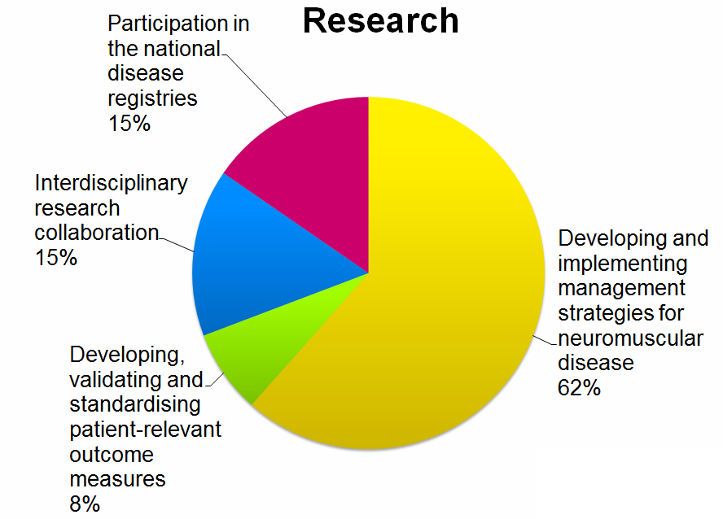

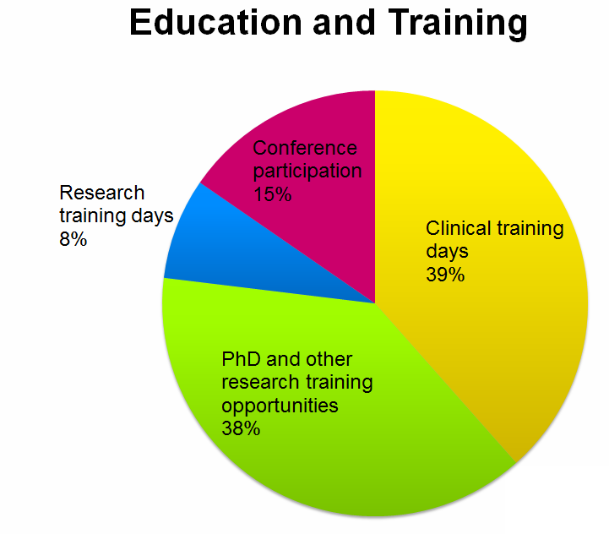

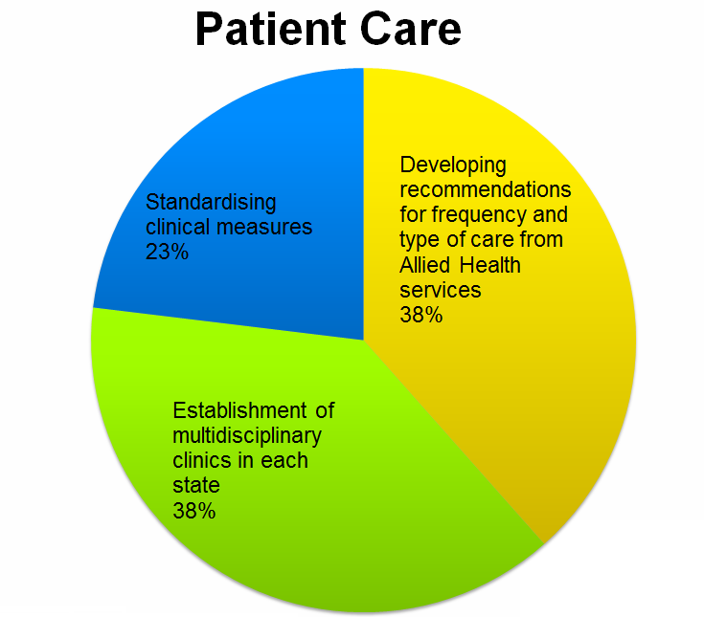

Figure 8: Proportion of Allied Health and Nursing member’s first priority rankings.

Research
The ANN will promote and facilitate the sharing of information and expertise between basic and clinical researchers, clinicians and clinician researchers, to accelerate improved outcomes for patients.
A collaborative network would allow large cohorts of patients to be included in gene discovery, screening and linkage studies, as part of a research work-up to underpin diagnostics, registries and clinical trials.
It is through research effort, for example, that the introduction of next generation sequencing and the analysis of large data sets (informing diagnosis and inclusion in registries) will be developed for translation into diagnostic laboratories.
The ANN is in the process of developing a national integrated secure database that will store patient data combining clinical, molecular and pathology data with longitudinal standardised assessments. This resource will be invaluable for clinical researchers in studies of natural history and genotype/phenotype correlation, and will provide a platform for research collaborations.
The development of a patient database goes hand in hand with gene discovery and improved diagnosis and clinical trial readiness. For example, when a new gene is described, a search of the database can be made for a clinical phenotype associated with the gene and then a search for those who don't have a diagnosis.

National patient database: Biogenix
Basic epidemiological data and information on the natural history of many rare diseases is very limited. However, this knowledge is essential to assess the impact of preventive or treatment activities and the implementation of best practice guidelines. Rare disease patient databases underpin improving clinical care and we aim to identify existing databases and prioritise and expand the collection of data for other rare diseases.
Australia is slowly developing patient registries, however they contain very limited information to largely determine if patients are eligible to enrol in a trial (eg. ambulant/non-ambulant; genetic diagnosis; walk time over a certain distance).
A critical step in the design of a clinical trial protocol is a more detailed database of patient information that is collected from researchers, clinicians and pathologists – a comprehensive set of data that describes the progression of the disease over time. This provides researchers and pharmaceutical companies with sufficient information to ensure that the outcome measures (how to determine the success of the trial) and the treatment are well designed for maximum benefit to the patient.
The proposed database for housing patient data and availability of muscle for research use will be a national centralised repository that will share inter-operability with existing registries established through the OPHG. The database will be incorporated into platforms that are to be developed as part of the RDConnect, RAREBestpractice and Neuromics programs.
The database will not duplicate the information stored in registries (post-diagnosis), but will add and link additional detailed levels of data on sub-sets of patients for gene discovery and investigator led genotype/phenotype and natural history studies (pre-diagnosis).
A working party will be established to develop an implementation plan and will address issues such as ethics, information to be stored in the database, access, retrieving data from existing databases to populate the national database and data entry (resourcing is being sought from patient groups, with an additional option of utilizing students as part of cohort studies).

National coordination

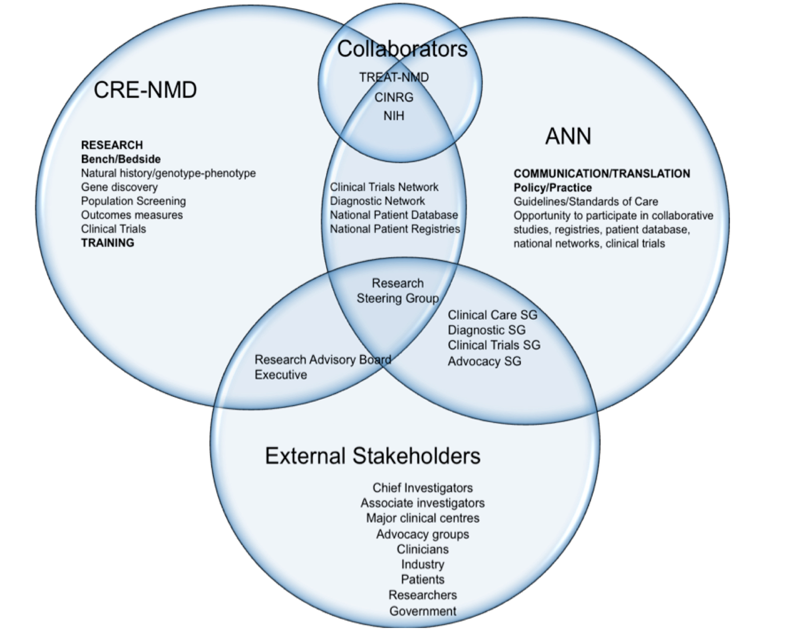

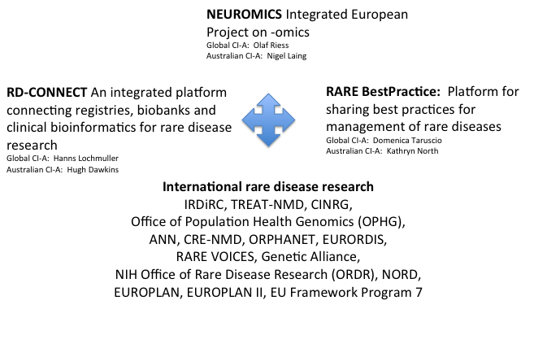
International coordination

Neuromuscular Community
The ANN/CRE-NMD has a number of community partners and is a member of TREAT-NMD and the FP7 Framework. The relationship with advocacy and patient groups is a very important part of the ANN.

